| AEPHY2024  **Narrogin SHS Year 11 ATAR PHYSICS Name: SOLUTIONS** |
| --- |

| Task No: | 4 |
| --- | --- |
| Task Type: | Test |
| Content: | Ionising radiation and nuclear reactions |
| Task Description: | Complete the attached questions in the spaces provided.  Marks will be awarded for presentation and working.  **Test conditions (50 minutes).**  *Formulae and data booklet provided.*  *Non-programmable calculator permitted.* |
| Total Marks: | 37 |
| Weighting: | 6% |
| Materials required | pens, pencils (including coloured), sharpener, correction fluid, eraser, ruler, highlighters, scientific calculator |
| Due Date: |  |

1. How is mass number different to atomic number? Use an example to assist with your answer

(2 marks)

1. Explain how differences between an alpha particle and a beta particle result in their different penetrating ability.
2. marks)

1. Americium -241 undergoes transmutation to Neptunium -237 as a result of radioactive decay.
2. Write a nuclear equation showing the type of particle emitted.

(2 marks)

1. Which property of the Am-241 nuclide makes it likely to undergo this type of decay? (1 mark)

1. A film badge worn by a nuclear medicine technician indicated the following monthly exposure:

gamma radiation: 0.2 Sv

beta radiation: 0.4 Sv

1. What is the technician’s absorbed dose for each radiation type?

(2 marks)

1. If the technician’s body mass is 70 kg, how much energy did her body absorb from the radiation? (2 marks)

5. Calculate the binding energy of a Th-228 atom (including electrons)

in MeV

(mass of proton – 1.00728 u)

(mass of neutron – 1.00867 u)

(mass of electron – 0.000549 u)

(mass of Th-228 atom – 228.0287 u)

(4 marks)

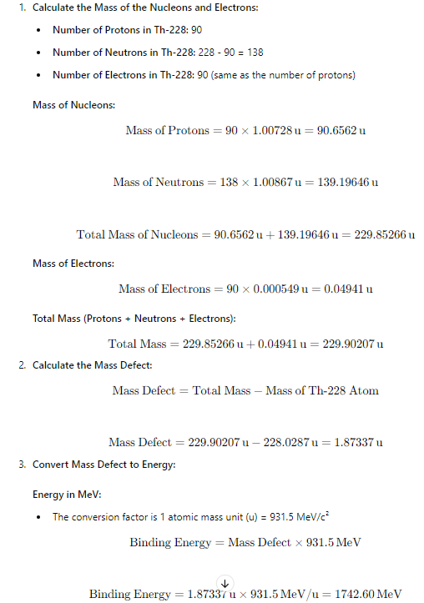

1. Calculate the energy released (in Joules) in the fusion reaction:

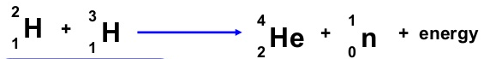

The masses are: H-2 = 3.344 x 10-27 kg

H-3 = 5.007 x 10-27 kg

He-4 = 6.645 x 10-27 kg

Neutron = 1.675 x 10-27 kg (4 marks)

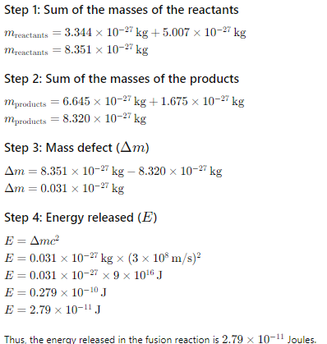

1. An original 100 g sample of uranium 232 decays to a mass of 6.25 g in 288 years. Calculate the half-life of U-232

(2 marks)

1. Examine the following picture of a nuclear reactor. Label the following parts
   1. shield
   2. control rods
   3. heat exchanger
   4. fuel rods
   5. moderator (5 marks)

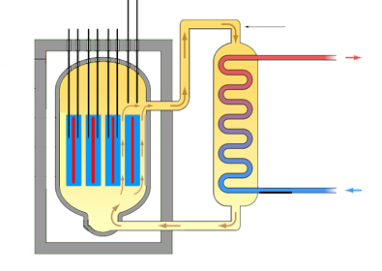

1. A sample of plutonium has been recovered by a NATO inspector. What features will be used to determine whether the sample is weapons grade or fuel grade? (2 marks)

1. Complete the following nuclear reactions.

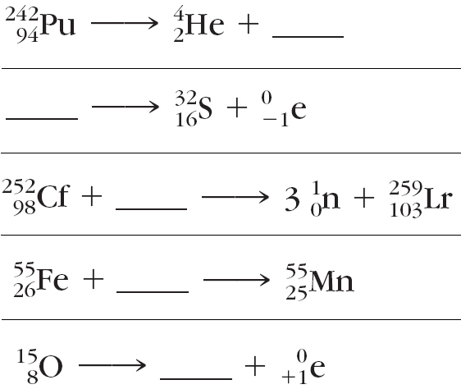

(5 marks)











End of Test